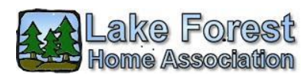
Lake Forest Board of Directors Minutes
April 19, 2022
Location: Evergreen Forest Elementary School Library
Board Members Present: Kathleen Emmett (P), Nan White (VP), Kim Busembark (T), Alex Bromen (MAL)
Board Members Absent: Deanna Rocamora (S)
Guests: 3
Time Started: 6:35 PM

Welcome and Call to Order
Minutes: Review and approval of March minutes – approved pending addition of March’s CC&R report, excluding Finances (not available)
Insurance: LFHA Insurance coverage paperwork for May 2022-May 2024 reviewed, edited, and submitted by mail prior to the April 19, 2022, deadline. Awaiting the company’s review and possible cost adjustments to final bill. Kathleen’s name is on the documents, and they will contact her with questions. No voted needed on the payment of this bill.
Treasurer Report (Kim Busembark)
- No written report submitted. Normal payments for month of April.
- Questions remain on current finances. Bookkeeper Shantel Jones hasn’t fully updated the LFHA 2022 Book Budget printout (handed out monthly at meetings) since January 2022. Questions on ending balance of 2021 budget, actual 2022 budget vs 2022 budget voted on, etc.
- Kathleen to request a special meeting with bookkeeper, 30 minutes prior to May’s meeting to get answers.
CC&R Report (Alex Bromen) – see end of minutes for full report
Highlights:
- Lot 1055 – executer estimates the CC&R violations, fines, evictions, to resolved in about 6 months.
- Incursions on greenbelts – Estimate for professional survey estimate $3200 for a partial survey of the LFD/Oxford/37th Ct greenbelt. Board requested estimate for entire greenbelt.
  - Issue tabled until May. Alex to contact surveyor
Maintenance Report (Jeff Heard) – see end of minutes for full report
Highlights:
- Work in Creighton greenbelt to remove ivy, blackberry, etc.
- Service parked for Easter Egg Hunt and clearing trails
- Removed ½ cord firewood from greenbelt, cleared trails. Firewood left along LFD for free distribution
- Harvard/Marquette greenbelt inspection
- Hazardous tree on LFD/Oxford/37th Ct. greenbelt
  - Several companies declined to bid
  - 3 bids secured, board voted to accept Treewalker, LLC’s bid. Jeff to contact company. Board voted to approved bid of $16,380, and the additional cost (estimate) of $200-$300 for Maintenance to tend to fencing issues as a result of the tree removal.
ARC Report (Nan White)
- Lot 3135 – Shed, approved
- Lot 1049 – Tree removal, approved
- Lot 3085 – Fencing, Paint – approved
- Inquiry about greenhouse in front yard, discussion – not likely approved
- Inquiry – Lot 1081 – did they get approval for gravel area within the last 6 months?
Events:
- Easter Egg Hunt: Resumed after 2 years due to pandemic. Volunteer Janet Lubach organized event. Around 100 attended event, all appeared to have fun and helped out.
- Calendar on LFHA website for Reservation of park events. Beckie Weatherford, website caretaker, has added calendar, but to continue use it will cost money. Nan to contact Beckie to delete calendar in favorite of a simpler format. Plan for calendar is to allow neighborhood to see what days, and areas, of park are reserved, prior to submitting a park reservation form.
Waterfront: Meeting of interested parties for the waterfront work was held during the month. Reviewed various styles of stone veneers for the retaining walls. Concern raised about fixing the bottom retaining wall (bulkhead) prior to cosmetic work. Handrails are needed. Follow up meeting to be held, TBA.
OLD BUSINESS
- Final stage of streetlight conversion to LED – Requires prepayment of $3400 (already approved) and have contract signed. Estimated work in 10-12 weeks. Jeff Heard to work with Lars Larson, official, on this project.
- Street Flooding on Creighton – This is a county matter. There is no known follow up from the county on homeowners or LFHA inquires. Drywell needs to be tended to by county. Last communication to LFHA by county was Feb 18, 2022, when county stated it would be turned over to engineers.
- Annual Audits – 2019, 2020, delayed due to pandemic. Beckie Weatherford has all paperwork needed for 2019 & 2021 audits. Kim Busenbark recently turned over 2021 audit paper to Beckie as well. Kim to look into audit reviews to be hosted by Diane Rigby via Beckie.
- Annual Yard Sale: 2.5’ x 6’ outdoor vinyl banners (3) have been received and will be put out near the 1st of May. Info to be place on entrances signs, social media.
- Meeting with RMR Lawn Services – April 11th meeting was cancelled by RMR. Has since dropped off paperwork on the changes he would like in his contract. Meeting scheduled for April 25th to review his request.
NEW BUSINESS
- Dog Waste Stations – Beckie will no longer be tending to dog waste stations in neighborhood. Notified Nan that she’ll drop of the keys and supplies to Nan soon. Guest at meeting volunteered to take over this position. Replacement dog waste station (for post near toilet in park) will be picked up from Thurston County office by Nan.
- Social Media – Beckie and Nan are sharing administrative duties for Facebook LFHA site. Unknown person is doing Next Door LFHA site.
- Theft of Plants in Park: general agreement that this was awful
- Shannon Hildreth was nominated and approved for a Member-at-Large position on the LFHA Board.
- Alex Bromen will be gone for the month of May.
Meeting Ended: 7.56 PM
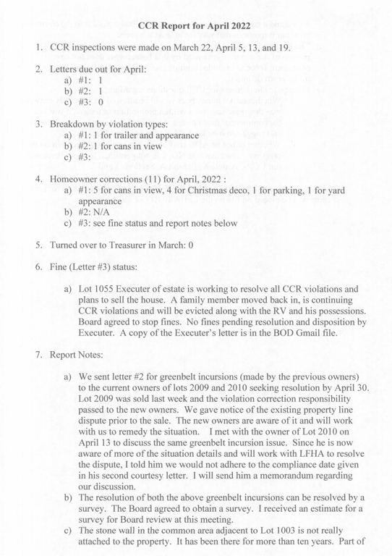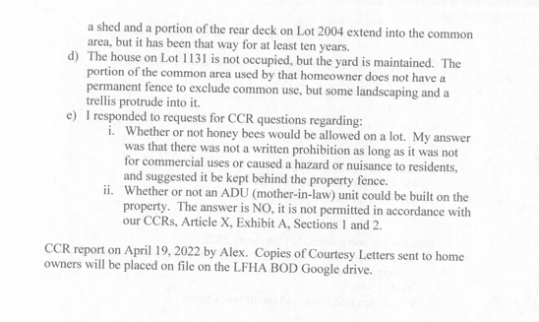

April 2022 Maintenance Report, sent via email from Jeff Heard
!. Worked green belt behind Creighton Ct, between Lk Forest Dr & Walthew. removed ivy & black berry brambles from trees, trail & resident's fences.

Serviced park in preparation for Easter Egg Hunt. Pulled blackberry brambles from lawn perimeter, removed dead saplings & down branches, cleared trails,
Hauled a pickup load of brush out of the park

Removed 1/2 cord firewood in Harvard green belt remaining from last years tree project. Stacked firewood for resident pick up along Lk Forest Dr
Firewood disappeared overnight.

Toured green belt between Harvard Dr & Marquette looking for hazardous trees. . No obvious major tree hazards identified. Cleared trail, reduced fallen branches to decomposable bio mass.

2. Hazardous fallen tree in green belt behind 8740 Oxford Dr

a. Interviewed seven tree services
Ron's tree service declined job
Melloy's tree service declined job
Asplund tree service declined job
Referral from Alan Brumstad did not submit bid

b. Capital Tree Service submitted a proposal involving crane service. Initial bid of $15,000 involved 1/2 day crane rental. Upon initial inspection of site by Ness crane Ness declined the job. Days later Ronnie at Capital Tree persuaded Ness to do the job with the caveat of eight hour minimum crane rental
Subsequent estimate to remove tree: $22,000

Bram Granger from Tree Walker Tree Service visited the site on three different occasions, developed a complex plan involving multiple rigging devices. Plan requires removal of multiple panels of resident's fence and reinstallation upon job completion. Bid does not include fence removal & reinstall.
Tree Walker Tree Service bid: $16,380

Full Circle Property Service. Bid solicited by Kim Busenbark. Bid similar in most respects to bid from Tree Walker, also does not include removing &
re installing multiple fence sections
Full Circle Property bid: $16,350

I am positively impressed by Bram Granger's cautious and professional approach to the problem. My recommendation is to accept Bram Granger's Tree Walker bid of $16,380

So far I have no definitive solution to the fence removal & re installation. Resident appears amenable, but process will require investment of $250 to $300 of lumber & hardware to reinforce fence sections before removal and two or three Assn volunteers to assist in process.

Bid details to follow under separate cover

