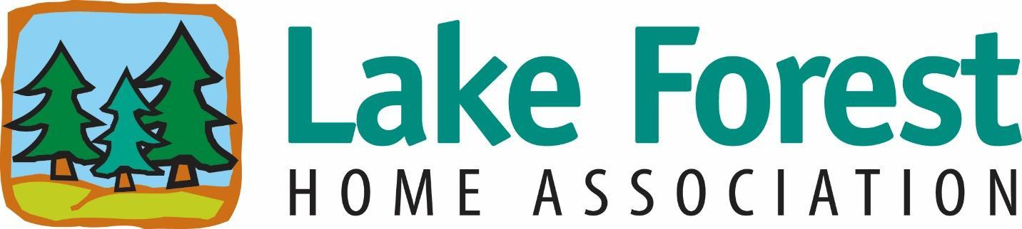
PO Box 3368, Lacey, WA 98509 | Phone 360 455 8324 | lfhabod@gmail.com

Welcome to Lake Forest! We are so glad you are here!
As a new member of our community, we would like to tell you about some of our amenities, activities, events and volunteer opportunities in the Lake Forest Home Association.
We have a wonderful lakefront park, Hearing Park that is available to all community residents in good standing with the association. Please contact our treasurer treasurer@lfha.net, for a gate code for entry into the park. We have an annual Easter egg hunt in April, a community wide yard sale in May, a Halloween decorating contest in October, and a holiday decorating contest in December. The board awards prizes for the decorating contests each year and we encourage all residents to participate. In addition, we keep the park open late every Fourth of July so residents can enjoy the fireworks over the lake. Each of the three entrances to Lake Forest have signboards where activities, board meetings, etc. are posted so all residents can know what is happening in our neighborhood.
In order to keep costs down, our home association operates with a volunteer board and no management company. Our volunteer board consists of President, Vice President, Secretary, Treasurer and 2-3 members at large. Board meetings are held monthly on the third Tuesday of the month and an annual meeting held in January of each year. These meetings are open to the public and are held at Hearing Park in the warmer months and Evergreen Forest Elementary School, 3025 Marvin Road SE, Lacey, WA 98503 in the cooler months.
Since we are a volunteer based association, we have additional volunteer positions available for residents to participate. We have a Monday Morning Maintenance Crew that performs maintenance jobs around the community, an audit committee that performs annual audit of our books, shoreline renovation project needs some volunteers to help with this ongoing project. There are also many other opportunities available which are all listed on our website, lhfa.info.
All of the information regarding our community, governing documents, forms, board members, contact information, park information, etc., are also available on our website, lhfa.info. If you cannot find the information you need on our website, please feel free to contact the board at our email address, LFHABOD@gmail.com. We can also be contacted via phone at (360)455-8324. If you should need information regarding your account with the association, please reach out to our treasurer at treasurer@lfha.net.
Once again, welcome to our community and we look forward to seeing you.

Kathleen Emmett
LFHA Volunteer President

