Lake Forest HOA Board Meeting
January 15, 2018
Meeting Minutes

Location: Lacey Fire Station #34, 8407 Steilacoom Dr., Lacey, WA
Board members present: Chris Sherin, Lorna Stewart, Nan White, Beckie Weatherford, Greg Landers, and Judi Denney
Board members absent: Chase Turner
Guests: 11
Time started: 6:30 PM
President’s Welcome - Welcome was given by Vice President Chris Sherin.
Secretary Report:
- December 2018 Board MInutes Approved

Treasurer Report
- Current accounts in arrears send to VF - 2 accounts have responded and are going on promise notes. 9 will be going to VF
- Clarification on how and what accounts go to VF - Beckie emailed VF
- Vote to pay Chris Shering for Godaddy domain deferred to February.
- Vote to reimburse Jeff Heard $45.77 for materials to cover damage to the dock. YES
- 149 homeowners have paid assessments.
- vote to add a clarification in Ryan’s maintenance contract for 12 hours of work to be performed in the neighborhood in months he does not mow. - YES
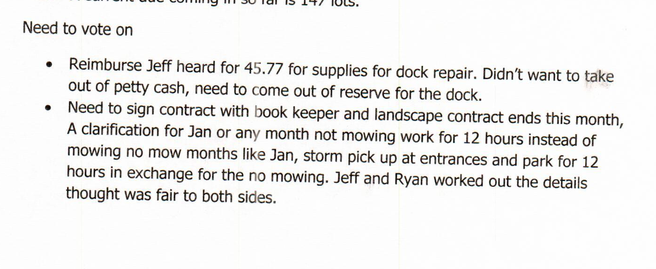

ARC Report:
- No requests

C C & R Report
- Lot 2062 update
- 4 lots to small claims as fines are over $400 - lot 1001, 2033, 3090 and 3138.
- CC&R’s were very low so volunteers did not send in reports.
- Lot 1029 - inoperable cars and whether grandfathered in to let these cars be in the driveway. Diane Rigby stated that when she was on the board, they had issues with this lot and inoperable cars. Nan and Diane will work together on this.
- Lot 3137 - running a small business? what to do. table to next meeting

Communication Report:
- Phone - 15 calls mostly regarding dues
- Facebook - 75
- lfha.net - no report
- Next Door - 379

Events Report:
- Holiday Decorating Contest was Dec 20th and 4 winners were chosen and $25 gift cards from Home Depot were mailed to the winners.
Shoreline Restoration Committee Report -
- Bid has been received from SCJ Alliance. Committee will meet January 16th to review and report back to the board.
- Might can use the tree that fell in future plans for the waterfront.
Long Lake Management Report:
- Kathleen Emmitt reported that the annual meeting for the Long Lake Management Committee will be held January 22, 2019 at the Lacey Community Center @ 6:30.
- In addition, Lake Forest has another position open to serve on the Long Lake Management Committee if anyone is interested.

Maintenance Report:
- Down Tree @ park that feel on dock. - tree is too large to move. Will reach out to the Long Lake Management Team for possible help in moving tree. Dock has been “patched” for now and damage is being assessed. Dock has also been cordoned off. Brush from top of tree has been removed from the dock. Will evaluate more later in the month.
- BK Tree Service will start the tree project on January 22nd.

*******Break for Annual Meeting*****

*******Resumed @ 7:30********

Old Business:
- New LFHA Website Project -domain is in the process of being transferred to Godaddy.com. New website should be up and running in the next week. will need to keep the treasurer.lfha.net email for PayPal. Holly Harmon volunteered to help with the website layout and design.
- Lot 1001 to attorney - voted to pay the attorney bill and not pursue further with the attorney. He is also parking on the greenbelt now - will contact the owner to remove the vehicle.
- Waive Audit of the 2017 books votes to be counted - Passed - Yes 122 No 22

New Business:
- Thurston County Crime Reports for December - none
- Homeowner Committee to Audit the 2017 books - Diane Rigby volunteered to chair the committee. Will push to February.
- Aex Bromen brought up to the board the possibly need for internet security & phishing training for board members - this will be taken into consideration by the board.
- Can we send fines to VF as well as fees? - Beckie to contact VF

End Time : 8:06 PM

