Lake Forest HOA Board Meeting
June 19, 2018
Minutes

Location: Lacey Fire Station #34, 8407 Steilacoom Dr., Lacey, WA
Board members present: Chris Sherin, Beckie Weatherford, Lorna Stewart, Nan White
Board members absent: Chase Turner
Guests: 11
Time started: 6:30 PM
President’s Welcome: by Beckie Weatherford, Secretary

Secretary Report:
- May 2018 Board minutes were approved with the 1 correction. Remove Shannon as an absent board member as she has resigned from the board.

Treasurer Report
- Waive the CPA audit for the 2017 books? Tabled to July meeting in order to test voting by email. Shantel to send test email by June 20, 2018.

- Vote - to approve paying balance of reserve study $750, reimbursing Nan $50 for stamps, and Lorna $7.01+$75.10 for tp and garbage bags and doggie poop bags - Approved

- Quarter 1 reserve balance transfer 1135.93 vote - tabled to July meeting. Request has been made to use this money for a shed.

- Vote Election Runner as our electronic voting mechanism- Approved

- Reserve Study - complete will be on the website in the next few days.
  - not enough money to do the waterfront - trying to get more bids and look at other options
  - suggestion has been made to hire a landscape architect for a proposal of what we want to have bid and then go out for bids
  - the retaining wall that is failing and moving could be done as a repair with cables and such which could be a stop-gap approach for now.
  - a sample vote of the members present of whether to build back walls or go with a more natural, sustainable landscape. Most people want the more natural landscape.

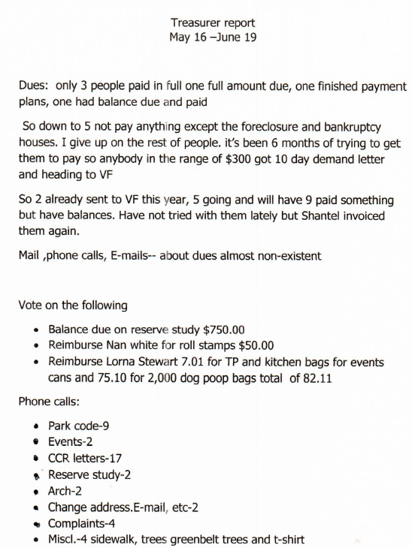
ARC Report:
- cat enclosure lot 2005, decorative fence lot 3080 and house paint colors lot 3096 were approved
- 2 other requests were received for approval

C C & R Report
- Parking on gravel is okay, bare dirt, fir needles, and beauty bark is not okay.
- Blue tarps (or similar tarps) are not okay for covering cars but car tarps are okay.
- How to verify if cars are operational. verify licenses are valid, make an appointment with owner to verify operational. it was also pointed out that the Outer Thurston County Rules as well as the CCR’s state non-operational cars cannot be on the lot - not just the front yard, After the third letter, Thurston County Junk Car Code Enforcement will be notified.
- Keeping the sidewalks walkable at corner of Marquette and Gonzaga. Sidewalks are the county’s responsibility. Also, Monday volunteers are working on various areas in the neighborhood.
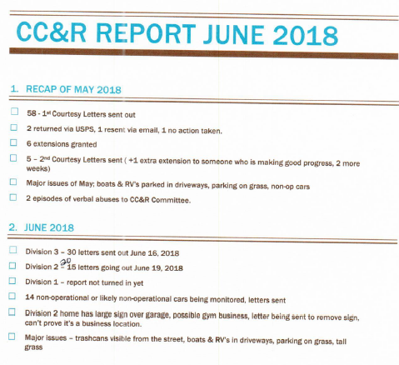

Communication Report:
- LFHA phone -42 See Treasurer’s report for breakdown
- LFHA website 37
- Nextdoor: “Lake Forest Lacey” (volunteer hosted, LFHA Board not responsible for content) 352
- Facebook: “Lake Forest Community” (volunteer hosted, LFHA Board not responsible for content) 77

Events Report:
- Summertime Park Events Volunteer needed to help with events scheduled at the park by homeowners. Meeting the people at the events to unlock gate, check on the guests, and at the end let them out and ensure they are taking their garbage out with them. Alex, Bromen Cindy Cartwright & Kathleen Emmett all volunteered to help.

- July 3rd Watermelon Event - cancelled.
- Park will be open to watch fireworks on July 3rd until fireworks end. Drive thru gate will be open.

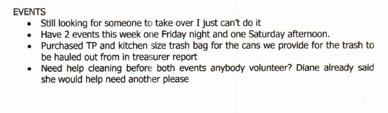
Long Lake Management Report: no report as we have no representative.

Maintenance Report:
- Beckie Weatherford volunteered to fill poop bag dispenser on Oxford Loop. Dallas D’Angelo will do the one in the park, Nan White to do the one between Harvard and Marquette by the orange chain. Fordham will be done by Cindy Cartwright
- Send a letter to homeowner that raised concerns over the contractor mowing.
- 5 trees in the neighborhood are questionable. Jeff Heard will review and then get with arborist as needed.
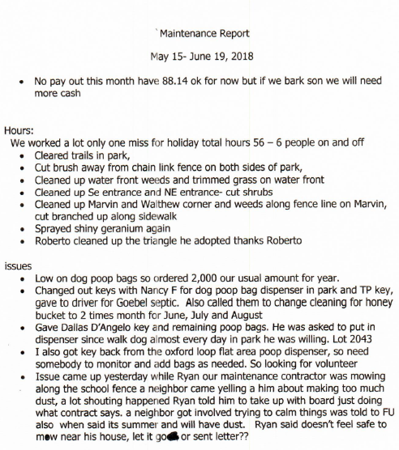

Old Business:
- City of Lacey Water Easement Project update - tabled to July
- Update CCRs division by division - clarify verbiage, change terminology etc. will need to have a work group session to review.
- Permanent storage unit on LFHA property to store supplies & records - after much discussion tabled to July meeting.
- Website issues for LFHA.net shop around - Nan has created a new live website via WIX.com for the board’s review lfha.info.

New Business:
- Using “late fee” funds to build off-leash dog park on Oxford Loop - Tabled to July 2018
- Thurston County Crime Reports for June 2018 - nothing to report as no crime had been identified
- Vote - Judy Denney and Greg Langer as Board Members at Large - Approved

End Time : 8:52 PM

