LFHA Monthly Board Meeting
July 16, 2019 - Minutes
Location: Hearing Park Pavilion
Board Members Present: Gregg Langer, Judi Denney, Beckie Weatherford, Nan White
Board Members Absent: Chris Sherin
Guests: 10
Time Started: 6:30 PM
President’s Welcome:
- This meeting will pause at 7PM – Special Meeting to count the votes for the Annual Audit and resume afterwards, if necessary.
Secretary’s Report:
- Waive reading of June Minutes and approve? Approved
- Vote to amend error on July 15, 2017 Special Meeting Notes to read 2017 instead of 2018, both online and original copies. Approved
- Online Minutes at lfha.info had a mix-up with wrong minutes posted for July 18, 2017 – instead were July 2018. Error was corrected with approved minutes of 2017.
Treasurer’s Report: See Attached Report
- VOTE – reimbursement to Jeff Heard $87.59 for dump runs, fuel, propane for weed burner. Approved
- VOTE – reimbursement to Nan White $48.00 for lamination of maps, Vistaprint bill, poster board.
ARC Report:
- Lot 3022 – paint, approved
CC&R Report:
- Vote – Lot 1001 Small Claims Court - Approved
- Lot 3100 – report of trailer and van out front, transients living in hooked up RV’s in the backyard. Plan to monitor lot
- Letter sent to Van Dorm Realty to remove the signs they placed on corners.
WRC Update and Long Lake Management Report: (out of sequence, arrived late) All permits except HBA submitted, HBA needs a letter.
Communications Report:
- Reported error of email links repaired on lfha.info
- 23 phone calls
- Facebook – 79 members
- Next Door – 412 members
Event’s Report:
- Old file of previous Welcome Committee letters, etc. Haven’t been able to locate old files of Welcome Committee in the shed
- 2 activities last month, no problems
Maintenance Report:
- 8 drainage ponds “done” for the county’s August deadline, 2 to go
- Removing rocks, bushes, trees and signage underway at SE Entrance
- Far end of Dock no supporting weight like it should, may need repair.
- Establish a Committee to Re-Landscape SE Entrance discussed briefly

Thurston County Crime Report: (6-18-2019 thru 7-15-2019)
- July 10, 2019 Hit & Run Accident, Lake Forest Court SE – looked up incident in Olympian newspaper, nothing found
Old Business:
- Volunteer Audit hosted by D. Rigby – no update
- Committee to sort through old LFHA records – haven’t met yet
- Welcome Committee already discussed
- Meeting with Polygon Homes representative on Friday, June 20, 2019 at 9am at the SE Entrance. Informed of removal of SE Entrance island, timeline.
- Sticky Stuff to repel fence jumpers at the park update Package says Non-Toxic, however instructions note that if product touches skin contact Poison Control. Did not pursue. Would “bird spikes” work? Secretary will look into.
- Replacing old cell phone for LFHA – Tabled, treasurer wants to look into more

Paused for Special Meeting 7:04 PM – 7:11 PM

New Business
- Key Control Update – handout of “key box” from shed, discussed tossing locks & keys that don’t work, keep good keys/locks, change out locks at NE Entrance Electrical Boxes and Fordham Doggy-bag station locks that have rusted closed or have no keys.
- Magnetic Business Cards – Board liked quality of test product, plan to order 100 and correct zip code error.
- Second Annual Audit vote (if needed) already discussed
- Review responsibilities of board members – tabled
- Appreciation Cook out for Monday Morning Work Crew – Judi to coordinate, possible dates August 19 or 26, lunch at the park, noon-ish
- Thurston County Corridor Improvements Meeting July 16, 2019 4:30-6PM – Secretary attended, 2 more traffic circles to be added to Marvin Road between already established traffic circle and the one being added at our SE entrance.
- VOTE - Bookkeeper requested an official vote to use Reserve Funds of approximately $11,834.55 to SCJ Alliance or other related companies for ongoing work of surveying waterfront, preliminary plans, and other work for Waterfront Restoration plans. Votes have been ongoing, but bookkeeper wanted an umbrella vote. Approved.

Time Ended: 7:27 PM
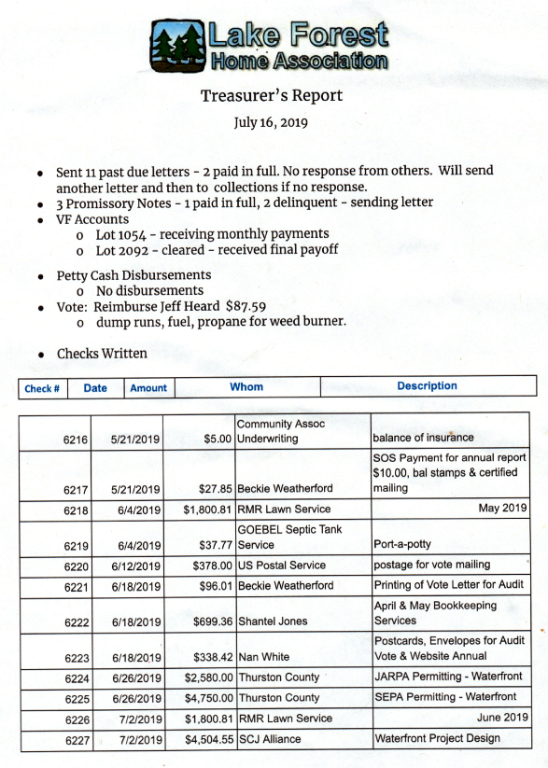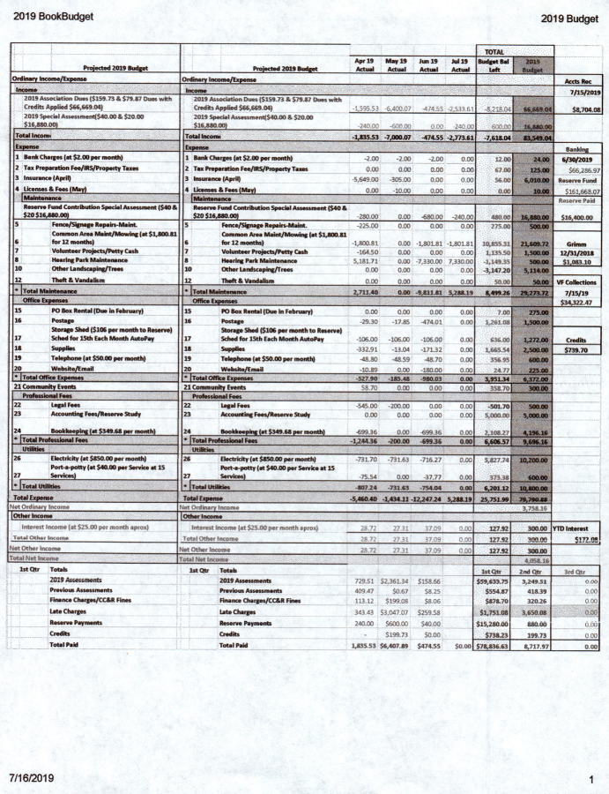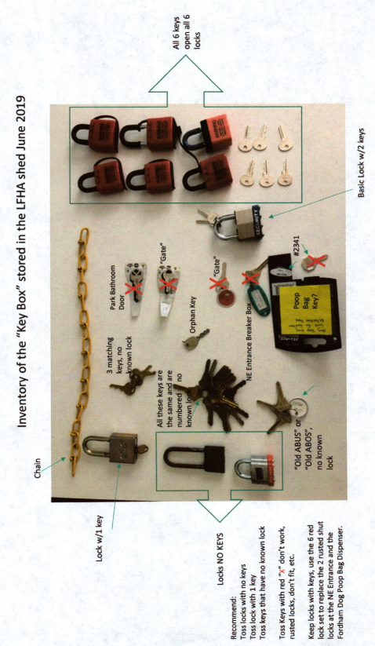

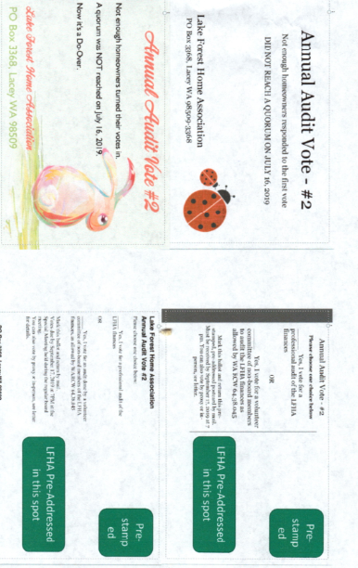

Special Meeting to count the votes for the Annual Audit waiver – July 16, 2019
Board Members Present: Gregg Langer, Judi Denney, Beckie Weatherford, Nan White
Board Members Absent: Chris Sherin
Time Started: 7:01PM
Total number of votes:
- Mailed in - 187
- Proxied
- Voted in person one person turned in postcard vote at meeting
- Two votes turned in to treasurer from secretary, one sealed in envelope, one printed out email.
Did this reach the quorum number required? No
- Number required is 67% of the number of votes mailed – Approximately 429 lots voted (lots with dues, late fees or interest or fines are not sent a ballot) 67% of 429 is 287.
If quorum is reached:
- Total number of votes for the professional audit of the 2018 finances for LFHA __________
- Total number of votes for volunteers (non-board members) to audit the 2018 finances of LFHA ____________
- Result:
If quorum is not reached:
- Second ballots to be mailed by 30-60 days prior to September 17, 2019 Special Meeting
- Next Board meeting is August 20, 2019 (Hearing Park)
- Next after that is September 17, 2019 (Fire Station #34)
- Bookkeeper volunteered to manage an electronic vote for the 2nd Annual Audit Vote
- Possible designs shown for the 2nd Annual Vote postcards, repeat information that will be on letter does not need to be on postcard. Treasurer requests that the LFHA logo be used.

Time Ended: 7:11 PM

