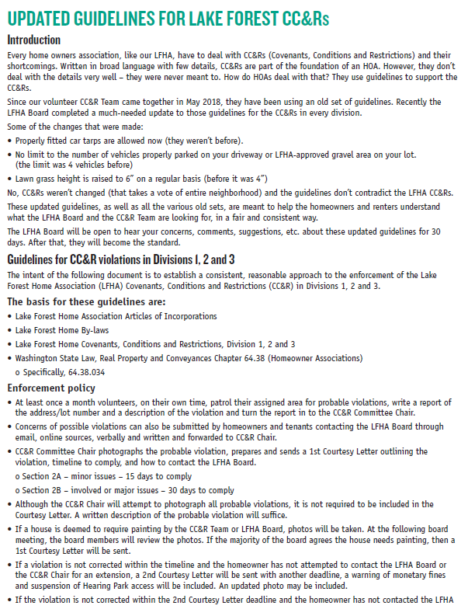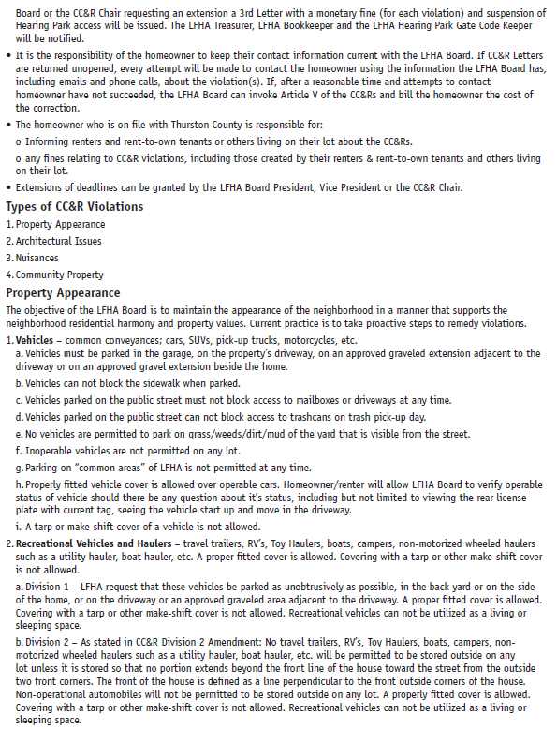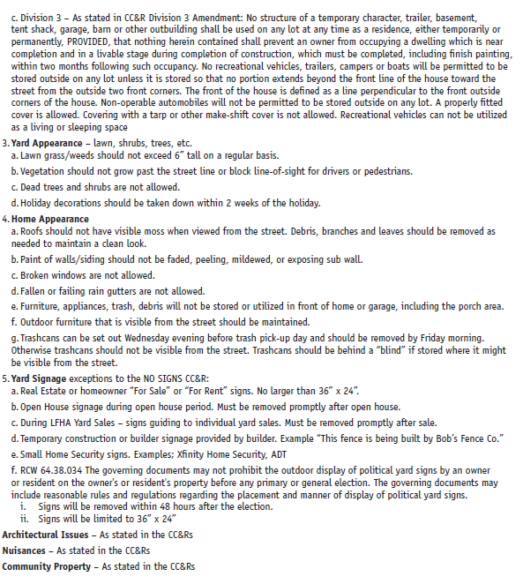

Adopted the Lake Forest Home Association at the October 2018 Board Meeting.
Published in LFHA December 2018 Newsletter
Sent via email to all verified homeowner emails on Dec 14, 2018 and mailed via USPS to homeowners without a verified email address.

