Lake Forest HOA Board Meeting
July 17, 2018
Meeting Minutes

Location: Lacey Fire Station #34, 8407 Steilacoom Dr., Lacey, WA
Board members present: Chris Sherin, Lorna Stewart, Nan White, Judi Denney, Gregg Lander
Board members absent: Chase Turner, Beckie Weatherford
Guests: 6
Time started: 6:30 PM
President’s Welcome
Secretary Report:
- June 2018 Board minutes were approved

Treasurer Report
- Waive the CPA audit for the 2017 books? Tabled to August meeting as Shantel is almost done with the email voting (adding new emails, removing bad emails, etc). About 303 homeowners were sent the test voting, about 40 emails were bad. Thurston county is falling behind on updating house causing issues with keeping contact information current.

- Vote - $57.90 to Nan for stamps and certified mail & $200.00 to Lorna for petty cash Approved

- Quarter 1 reserve balance transfer 1135.93 vote - tabled to August meeting. Request has been made to use this money for a shed.

- Reserve Study - not on the website yet

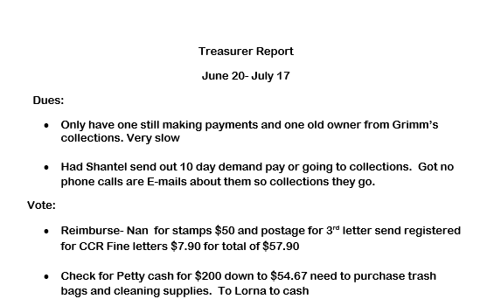
ARC Report:
- lot 1009 - driveway - approved
- lot 1111 - paint - approved
- lot 3165 - paint - approved
- lot 3179 - gravel for parking area next to driveway - approved
- Statue of lot 3137 with chicken wire fence. Wire on fencing appears good, fence posts not painted on both sides. Chris and Chase to discuss
- Lot 2033 using a tarp as garage door.
- Guest asked question regarding a silver BMW speeding in the neighborhood - response was that speed bumps are expensive and must be bought in pairs. A small red car is also reported as speeding .

C C & R Report
- Division 1 - 4 #2 letters, 17 #1 letters
- Division 2 - 2 #2 letters, 16 #1 letters
- Division 3 - working on
- 5 letters sent in June to remove dead trees/bushes, all 5 resolved
- Only 6 of the 14 non-op vehicles being monitored are still at issue. 2 new ones may be added to the list.
- Division 2 & 3 have shown good improvement in storage of RV’s and boats.
- Fencing along Kyro Road, some problems, letters to be sent.
- 2 known yards, one in Division 2 and one in Division 3 have backyards that are only partially cared for by homeowners. Other areas are left wild, one with cement blocks and blackberries gone wild. Do we expect homeowners to care for the wild areas? Both yards have fencing between cared for areas and wild areas.
- No written report - Nan did report from memory.

Communication Report:
- Phone quiet
- Facebook - 76
- lfha.net - 360
- Next Door - 344

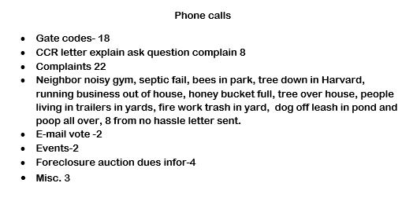
Events Report:
- July 3 Fireworks across the Lake event, some folks attended. Should verify fireworks events ahead next year. Lacey’s fireworks was announced as July 3 for this year.

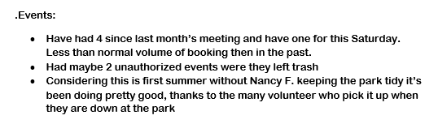
Long Lake Management Report: no report as we have no representative. Lake Forest is allowed 2 volunteers for the Long Lake Management committee.
Maintenance Report:
- Hornets, yellow jackets or bees are reported in the parking area of Hearing Park and inside. Treatment to follow.
- Beckie has dog poop bags, Robin has key, Lorna has 2 keys, there is no backup key for the Dog Poop stands. Someone on Radcliffe has complained that people are letting their dogs loose in the common area and they are pooping all over. The “orange chain” dog poop stand is not used, can it be moved to Radcliffe. “Yes”
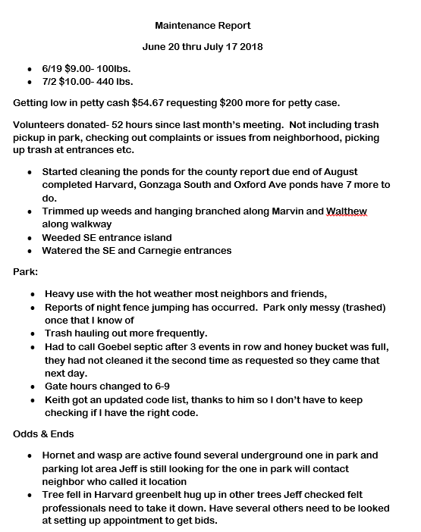

Old Business:
- City of Lacey Water Easement Project update -signed by Chase
- Waterfront Bulkhead Repair - ongoing, no new bids
- Update Guidelines Project:
  - Changes recommended:
    - No limit on the number of cars per household
    - Add the line “properly fitting vehicle tarp” into section
    - Vegetation in street – reference line-of-sight, that’s what the county uses as a term.
    - Delete using City of Lacey summer water schedule
    - 4B – House paint.
      - June 2018 – Board agrees that the opinion of a CC&R volunteer saying that a house needed paint was good enough and would stand behind the decision.
      - July 2018 – Board changes mind. Photos to be taken of homes reportedly needing paint, then the Board will vote on each home photo submitted. Nan requests that each board member then sign the photo with their name and their vote.
    - 4F - Remove any statement that says if a violation, problem, issue can be view from a neighbor’s property. Any complaints lodged by a neighbor for what they have to view from their property will be taken up on a case-by-case basis. Don’t want homeowners to think the board is snooping over their fences.
VOTE to make these changes to the updated guidelines – approved.

- Storage Shed Project:
  - Check on insurance coverage
  - Check if lawyer thinks we can legally use shed for storing information.
  - Pricing on 6’x10’ and 8’x10’ shared
  - tabled to August
- New LFHA Website Project:
  - some of the graphic designs are not liked
  - the use of first and last names was not liked
  - 2 board members had not viewed the new website
  - tabled to August

New Business:
- Using “late fee” funds to build off-leash dog park on Oxford Loop - Tabled until other issues can be completed
- Thurston County Crime Reports for July 2018 - 2 reports of burglary on Citadel - same home, 1 report of a suspicious person in Division 2

End Time : 8:30 PM

