Lake Forest HOA Board Meeting
May 15, 2018
Minutes

Location: Lacey Fire Station #34, 8407 Steilacoom Dr., Lacey, WA
Board members present: Robert Chase Turner, Chris Sherin, Lorna Stewart, Nan White, Beckie Weatherford
Board members absent:
Guests: 6
Time started: 6:30
President’s Welcome: Chase gave welcome

Secretary Report:
- April 2018 Board minutes yea/nay - Approved

Treasurer Report
- Waive the CPA audit for the 2017 books? Tabled until June meeting in order to do more research and try out the electronic voting. information was to go out via Nextdoor and Facebook regarding electronic voting and updating email information for the residents of Lake Forest.
- Vote to reimburse Lorna $10 for State sec annual nonprofit report and $34.25 garage sale ad - total of 44.25 - Approved
- Vote Reserve Fund Study - Association Reserves to do on-site study for the Reserve Fund at a cost of $1500 - Approved
- Vote to reimburse Nan $31.59 for materials for sign boards - Approved

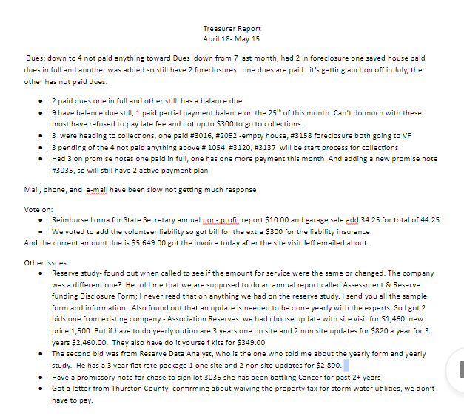

ARC Report
- lot 1046 approved fence for back of lot

C C & R Report

- Division 1 - no report was turned in from volunteer, Division 2 report was sent in and letters sent out, Division 3 report was sent in but letters have not gone out yet.
- Work group to discuss and define rules & fees for CC&R’s

Communication Report:
- LFHA phone see below
- LFHA website 338
- Nextdoor: “Lake Forest Lacey” (volunteer hosted, LFHA Board not responsible for content) 338
- Facebook: “Lake Forest Community” (volunteer hosted, LFHA Board not responsible for content)
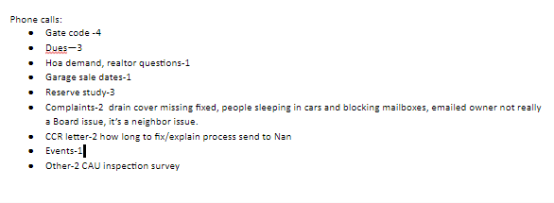
Events Report:
- Summertime Park Events Volunteer - has not been filled yet
- July 3rd community watermelon social at Hearing Park 9:30 -11:00 pm to coordinate with fireworks show. - to be voted on at June meeting
Long Lake Management Report: No Report

Maintenance Report: see below
c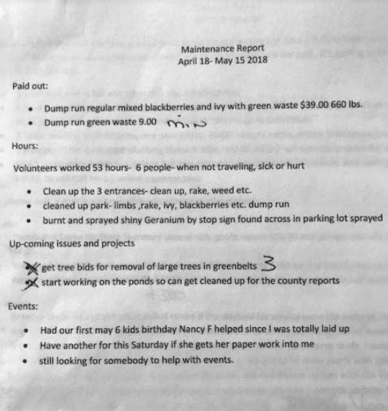
Old Business:
- City of Lacey Water Easement Project update -
- Setting Goals for LFHA Board for 2018
  - Waterfront bulkhead repair - discussed options of hiring someone for the waterfront repair.
  - Permanent storage unit on LFHA property to store supplies & records - record retention was discussed and options to house the documents we need to retain. - cloud based, hard copy, or hard drive.
- Shantel’s contract was signed and renewed for another year.
- Idea for recruiting volunteer board members -
- Voted: to send postcards out to the neighborhood recruiting new board members - approved
- Website issues for LFHA.net shop around

New Business:
- Using “late fee” funds to build off-leash dog park on Oxford - Tabled from May
- Thurston County Crime Reports for May 2018

End Time 9:04 pm

