Board of Directors Meeting
19 November 2019
Minutes
Location: Lacey Fire District Station #34, 8407 Steilacoom Drive SE
Directors present: Chris Sherin, President
Gregg Langer, Vice President
Beckie Weatherford, Treasurer
Kathleen Emmitt – Member-at-Large
Directors absent: Judi Denney, a Member-at-Large (Events)
Called to order: 6:30 pm by Chris
Visitors: 5

Welcome by President Chris Sherin
Vote: Add Kathleen Emmitt as Member-At-Large - PASSED
Secretary’s Report:
- Minutes for October 2019 meeting approved.
Treasurer’s Report:
- see attached report
Architectural Review Committee (ARC) Report:
- no requests
Covenants, Conditions, & Restrictions (CC&R) Report:
- Chris to follow up with Nan regarding CCR items
- Creighton Court issue - trailer with skids parking in round about
Communication Report:
- Phone calls minimal
Events Report:
- Holiday Decorating Contest December 19th
- Spooky Decorating Contest in October was a success!!
Long Lake Management District
- Annual meeting January 28th, 2020 6:30 Lacey Community Center – algae management
- Petition going to the County Commissioners asking for a $34 increase to all parcels on Long Lake to pay for a whole lake treatment. If our neighborhood has to pay this $34 increase we would pay 40% cost of treating the lake. We only have a very small area on the lake. Kathleen is following up with the committee
Waterfront Restoration Committee:
- Permit application is complete and public review is complete
- One neighbor of the park has requested a tree be preserved
- Dept. of Ecology, we are in the Tacoma Smelter Plume - Kathleen has a meeting with an Ecology representative to review Samples will need to be taken and analyzed
- Thurston County Conservation to give us a pre-assessment of our shoreline project
- Hearing in January or February – can start probably in the fall
Maintenance Report:
- Working in the Harvard/Lake Forest greenbelt and the park. Have taken down close to 20 trees.
- Cleaning sidewalks along Walthew Drive as well
- More volunteers needed for the Monday Morning Work Crew.
- Maintenance of sidewalks along Lake Forest Drive – have county come out and grind some of the edges
- Thurston County will let us use a shredder for tree debris. Kathleen to look into
Old Business:
- File cabinet for storage shed - put on hold will reevaluate the space in the shed and if it is really needed.
- Debit Card received
- Proposed 2020 budget - reviewed and approved by board. Will be sent out with newsletter
- Vote – Transfer $5,706.95 from Reserve Fund to pay for Waterfront Project - PASSED
- Annual meeting will be January 21st, 2020 and overviews by each committee will be needed
- Invoices to be sent out end of November & Newsletter to be sent out in December
- Will need volunteers for President, Secretary, Member-at-large, and Treasurer for next year.
- Need CC&R chairperson volunteer as well as website manager volunteer.
- Transfer money to reserve fund at the end of the year for 2018 & 2019.
New Business:
- New Cash Flow Enhancement received from VF, Vial Fatheringham – Reviewed New CFE and had a couple of questions regarding when an account goes to bankruptcy. We agreed to sign after Beckie follows up with VF.
- Vehicles & trailers parked in round-about on Creighton – Chris to follow up with resident
- Kathleen shared information she gathered from the Lacey HOA Academy Meeting. LawReporter website has information regarding HOAs
- Identify the volunteers in the neighborhood somehow.

Adjourned: 7:41pm

- 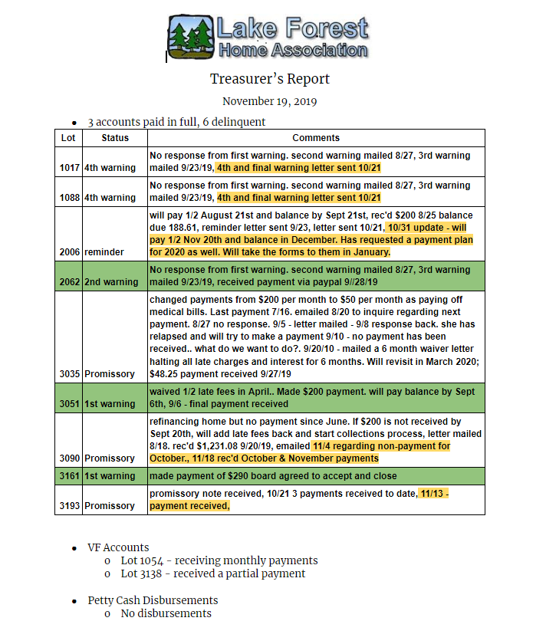 Petty Cash Disbursements
  - No disbursements

- Checks Written

Check # | Date | Amount | Whom | Description

6250 | 11/5/2019 | $35.00 | City Of Lacy | HOA Academy - Kathleen Emmitt
6251 | 11/5/2019 | $1,800.81 | RMR Lawn Services | October services
6252 | 11/6/2019 | $37.77 | Goebel Septic Tank | Port-a-potty
6253 | 10/22/2019 | $349.68 | Shantel Jones | September 2019 bookkeeping
6254 | 10/22/2019 | $37.77 | Goebel Septic Tank | port-a-potty
Debit Card | 10/29/2019 | $39.51 | DogPoopBags.com | dog poop bags
Debit Card | 10/29/2019 | $163.95 | Consumer Cellular | change cell phone company and new phone
Debit Card | 11/2/2019 | $95.00 | Home Depot | gift cards for Halloween decorating contest

